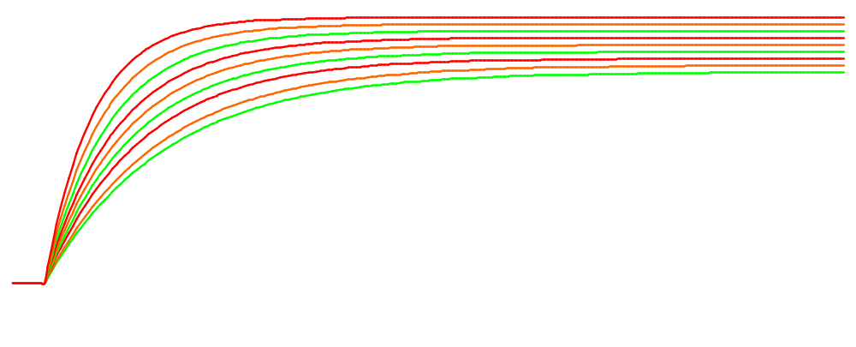
220 V
Dich
DC/FC
BITE
OK - Failure
SCAO
Terminal de gestion culinaire USB – USB cooking management terminal - Prototype N° 2 – Version 2


